Name:................................................................................ Index Number ............................................

Class....................................................................................Signature.....................................................

232/1
PHYSICS
PAPER 1
(THEORY)
December 2021
TIME: 2 HOURS

BUNAMFAN CLUSTER EXAMINATION 2021
Kenya Certificate of Secondary Education (K.C.S.E)
232/1
PHYSICS
PAPER 1
(THEORY)
TIME: 2 HOURS

INSTRUCTIONS TO CANDIDATES
- Write your Name, Index number and Class in the spaces provided above.
- This paper consists of two sections: A and B
- Answer all the questions in the spaces provided
- All working must be clearly shown.
- Mathematical tables and electronic calculators may be used
- Take g=10ms⁻²
- Density of mercury = 13600 kg/m³

For Examiner’s Use
SECTION | QUESTION | MAXIMUM SCORE | CANDIDATE’S SCORE
A | 1-12 | 25
B | 13 | 12
 | 14 | 10
 | 15 | 10
 | 16 | 12
 | 17 | 11
TOTAL |  | 80

This paper consists of 11 printed pages. Candidates should check the question paper to ascertain that all pages are printed as indicated and that no questions are missing.
SECTION A (25 MARKS)
Water Paraffin
Answer all the questions in the spaces provide

- The figure below shows a body resting on an inclined plane. Indicate the normal reaction
(1 mark)
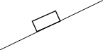

- The figure below shows two identical bulbs A and B painted white and black respectively connected with a pipe containing water at the same level at the room temperature.

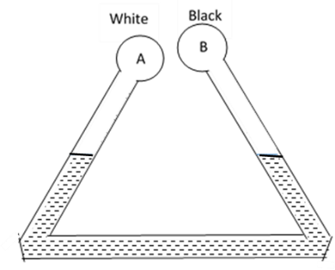
State and explain the observation made when ice cold water is poured on the bulbs
(2 marks)
…………………………………………………………………………………………………
…………………………………………………………………………………………………
…………………………………………………………………………………………………
- A boy blows through the mouth of a hollow vuvuzela as shown below. A light cork is suspended freely by a string as shown. Giving reason indicate the path taken by the cork
(2 marks)
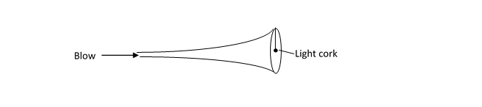
…………………………………………………………………………………………………
…………………………………………………………………………………………………
…………………………………………………………………………………………………

- The figure below shows a hollow metal cylindrical tin. A student used a vernier caliper and a micrometer screw gauge to determine the external and internal diameter of the tin respectively. The readings of the instruments are as shown below
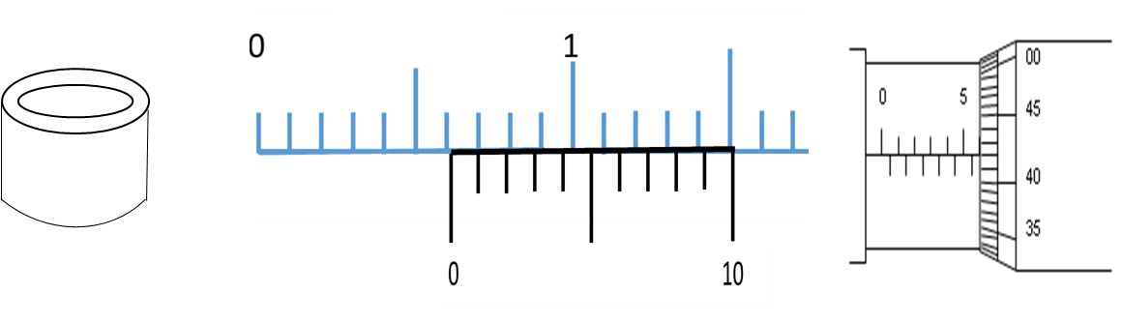
Determine the thickness of the metal used to make the tin in SI unit leaving your answer in standard form (3 marks)

- The figure below shows the level of mercury and water in a beaker.
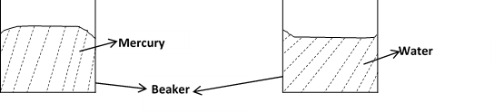
Explain the difference in the shape of the meniscus (1 mark)
…………………………………………………………………………………………………
…………………………………………………………………………………………………
…………………………………………………………………………………………………

- When an inflated balloon is placed in a refrigerator, it is noted that its volume reduces. Use kinetic theory to explain this observation (2 marks)
…………………………………………………………………………………………………
…………………………………………………………………………………………………
…………………………………………………………………………………………………
…………………………………………………………………………………………………
…………………………………………………………………………………………………
…………………………………………………………………………………………………
- The figure below shows a solid just before being released into a liquid of the same density as the solid. On the same diagram draw the observation made when the solid is released
(1 mark)
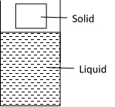

- The figure below shows a glass tumbler partly filled with water at room temperature.

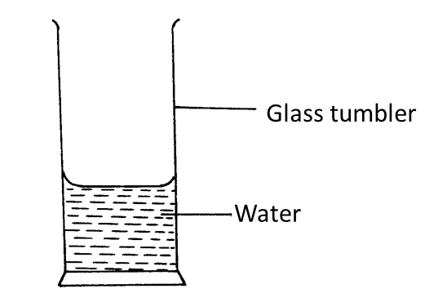
Briefly explain what happens to the stability of the tumbler when the water is heated
(2 marks)
…………………………………………………………………………………………………
…………………………………………………………………………………………………
…………………………………………………………………………………………………

- The figure below shows some air trapped in a glass tube, the tube is inverted in a dish containing mercury.
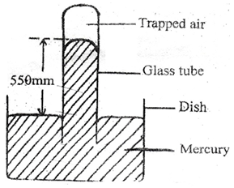
Given that the atmospheric pressure is 760 mmHg and the height of mercury column in the glass is 550 mm determine the pressure of the air trapped in the tube in mm Hg. (2 marks)

- The figure below shows a hydraulic machine in equilibrium while supporting a load when a force of 100N is applied one of the pistons. The cross section area of the pistons are as shown. Determine the weight of the load (3 marks)
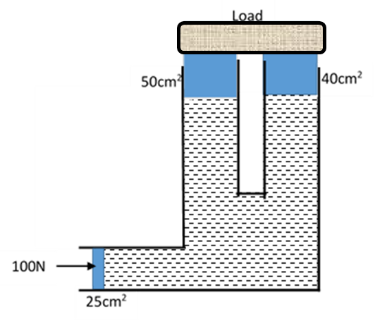

- A metal ball suspended vertically with a light string of length 4m is displaced through an angle as shown in the diagram below. The body is released from A and swings past the lowest point B. Given that its velocity at point B is 4 m/s, determine angle ϴ (3 marks)
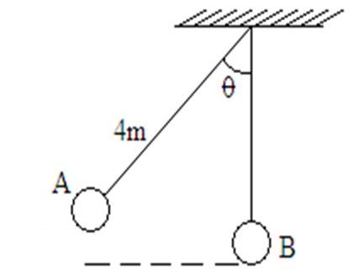

- The figure below shows a uniform bar balanced by forces F₁ and F₂. Determine the value of F₁ (3 marks)

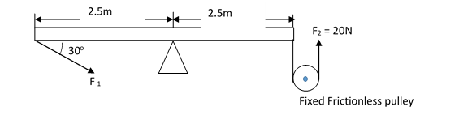

Radius 50cm
SECTION B (55 MARKS)
Water Paraffin
Answer ALL the questions in the spaces provided

- (a) An object of mass 50g is dropped from a height of 80m to hit the ground below
(i) For the motion, on the same axes, sketch and label the graphs of : (3 marks)
I. Kinetic energy against time
II. Potential energy against time

(ii) Determine how long it takes to reach the ground (2 marks)

(iii) Determine the momentum as it hits the ground (3 marks)

(b) Engine oil licks on the ground from a lorry as it decelerates uphill. The oil drops are shown below
as black dots. The time between any two drops is constant at 2sec
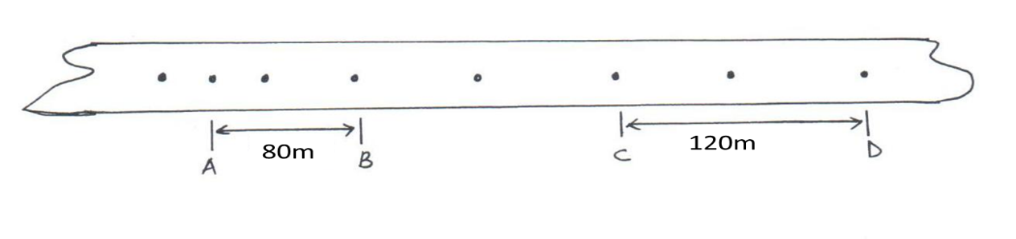
- On the same diagram indicate the direction of the lorry with an arrow (1 mark)

- Determine the acceleration of the deceleration of the lorry (3 marks)

- The figure below shows a system used to lift a septic slab of weight 150N by applying a force of 50N on a light bar as shown. The radii of the pulley belt wheels are as indicated in the diagram
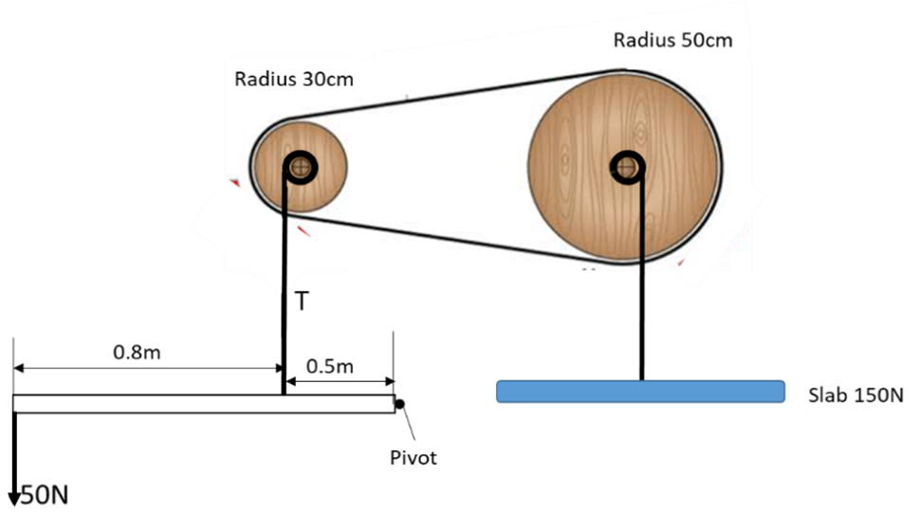
Determine
- Tension T of the vertical string (3 marks)

- MA of the system (2 marks)

- VR of the system ( 3 marks)

- Efficiency of the system ( 2 marks)

- a) State three factors that affect the toughness of a spring (3 marks)
…………………………………………………………………………………………………
…………………………………………………………………………………………………
…………………………………………………………………………………………………
…………………………………………………………………………………………………
…………………………………………………………………………………………………
b) When a mass of 120g is applied to a spring the pointer reads 6cm. A pan, in which a mass
of 210g is placed, is now suspended from the spring and the pointer reads 14cm. When
the 210g mass is removed from the pan the pointer reads 4cm.
  - Draw a diagram or diagrams to represent the information above (1 mark)

  - Determine the mass of the pan. (3 marks)

c) The figure below shows a mass 200g placed on a frictionless surface and attached to a spring.
The spring is compressed and released. Given that the elastic potential energy of the
compressors spring is 2.7x10⁻²J. Determine the maximum speed with which the blocks moves
after released. (3 marks)
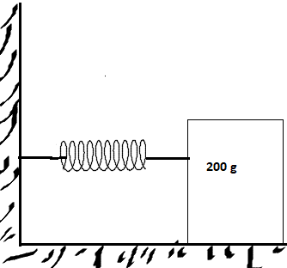

- The sphere below has a volume of 0.1 litres. It is held with a tight string at the base with ¼ of its volume in liquid A of density 380kg/m³ while the rest is in Liquid B of density 700kg/m^{3.} The tension of the string is 0.32N
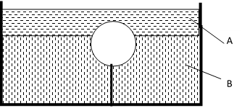

Find
- Mass of liquid A displaced (2 marks)

- Mass of liquid B displaced (2 marks)

- Upthrust experienced by the sphere (2 marks)

- Mass of the sphere (3 marks)

- Density of the sphere (3 marks)

- A girl joins two 20g masses A and B on a string and whirls them in a vertical circle Centre O of radius 50cm as shown below. The bodies maintained an angular velocity of 10 Rad^{-s}
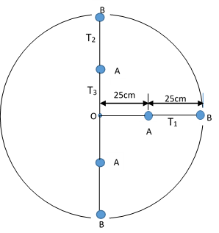
Determine:
- The linear velocity of body A (2 marks)

- Centripetal acceleration of Body B (2 marks)

- The tension of the string
- T₁ (2 marks)

ii. T₂ (2 marks)

iii. T₃ (3 marks)

